1. Build your enclosure, following the following picture as a guide:

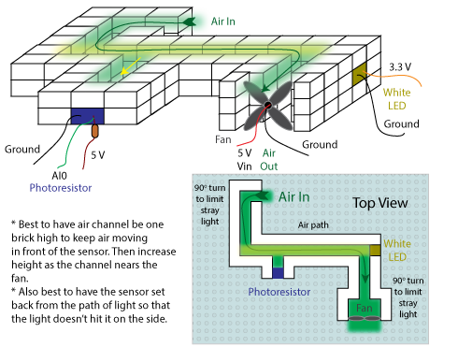

1. For the fan, I found the below setup to work best. MAKE SURE that air is being pushed into the system and not pulled. There are too many cracks in the legos and holes in the system to get enough suction out the other end if the air is pulled through the system.

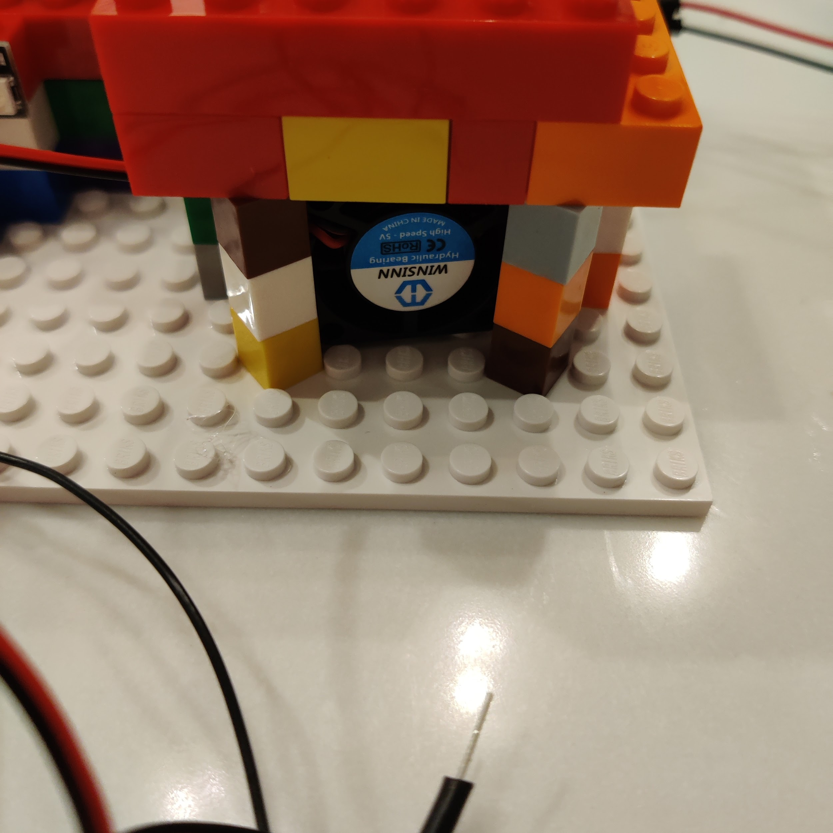

1. Plug in the micro-usb cord into the microcontroller, and the USB end in the wall socket.
2. The neopixel display will follow the below sequence:
   1. First, the lights will perform a **rainbow animation** to indicate that power is properly applied to the system. This lasts ~1 second.
   2. Next, the machine will go through a calibration cycle. The lights will first turn **yellow** and then **cyan**. If at any point in the calibration cycle the microcontroller detects an error, the lights will turn **purple** and flash for five cycles.
   3. Next, the strip will become solid **yellow**. This is the first calibration stage. If an error is detected, the lights will change to **purple**. To troubleshoot the errors, see the [troubleshooting documentation](https://docs.google.com/spreadsheets/d/169syWACnSGSg9ZBuyg8gWDcjOiGvT76oc5x60QT0W34/edit?usp=sharing).
   4. If the microcontroller successfully calibrates, the lights will switch to either being **red** or **off**. This is the measurement stage, and the number of lights represents the relative air quality. The microcontroller is programmed to display a measurement relative to what it remembers since turned on. Therefore, the initial measurements will seem really weird, like a clean air rating of 6/8 lights. Once you expose the microcontroller to polluted air values, the microcontroller will have a better understanding of what “polluted air” looks like, and will adjust the display accordingly.

** for steps A-C, make sure that no particulate matter is flowing through the system. If the system is calibrated incorrectly, it will not read the correct relative air pollution.